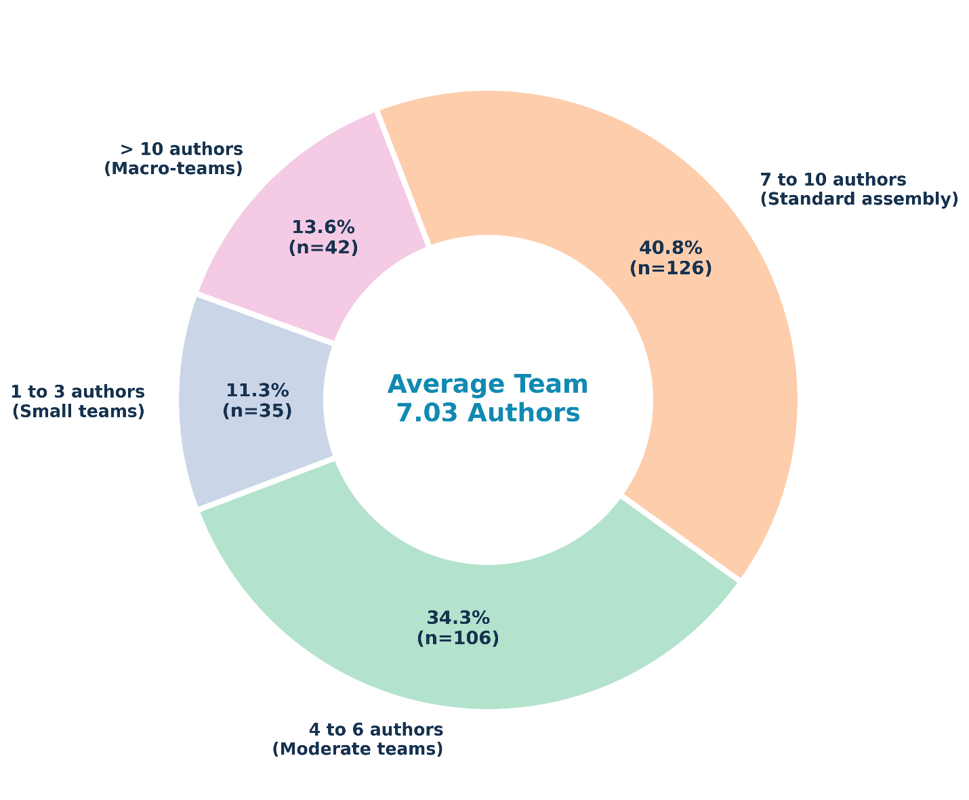
Figure 4. Collaborative research team trends. The donut chart shows the extent of research teams in publications. The average research team for papers consisted of 7.03 authors.

